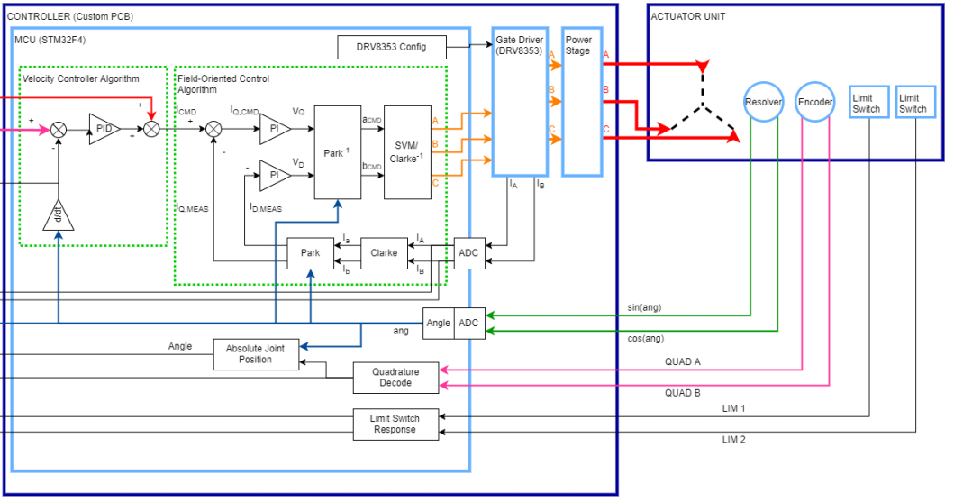

Code to write:

Park/Clarke Forward and Reverse functions

IQ CMD and ID Meas PI loops

ADC code for sampling IA and IB from motors

Velocity Controller Algorithm

DRV configuration Software for 6x PWM and setting for Gain on shunt amplifiers

PWM configuration code for STM32F303RE for all 6 channels

Priority code in order:

1. PWM configuration code for STM32
2. ADC code for sampling IA and IB
3. DRV configuration code for 6x PWM and chosen Gain on shunt amplifiers
4. IQ and ID meas PI loops
5. Park/Clarke Forward and Reverse Transforms
6. Velocity Controller Algorithm

Enabling PWM Channels on the Nucelo

Voltage → Duty Cycle (Write to Phase)

Notes: I anticipate writing the PWM and ADC configuration code will take the longest, as we will need to test both extensively. We can ask HWI for assistance however in this effort. Park/Clarke code should be relatively copy and paste from existing sources and the Velocity controller algorithm and PI loops should be relatively ok to write.

Notes for ADC program: We should return info in terms of current:

Should follow this conversion equation: 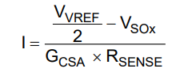

Gcsa is configurable to 5,10,20,40 (in 6x it is 5V/V)

Rsense = 0.001 ohms

Vref = 3.3V

Vsox = input to ADC

* 3 separate ADC channels

**ADC**

**Questions**

* Where is ADC_init being called from?
* Where is the STM32 board documentation?
  + Reference manual: <https://www.st.com/content/ccc/resource/technical/document/reference_manual/4a/19/6e/18/9d/92/43/32/DM00043574.pdf/files/DM00043574.pdf/jcr:content/translations/en.DM00043574.pdf>
  + Datasheet: <https://www.st.com/resource/en/datasheet/stm32f303re.pdf>

**Requirements**

* Configure a 12-bit ADC
* Need to sample 3 separate voltages
* Must sample at > 10kHz
  + The faster, the better
  + Probably be somewhere around 10-15kHz, 20kHz would be nice
* Figure out:
  + If we want to sample three separate currents, can we use 3 separate channels on one ADC or do we need to use 3 ADCs

**Notes**

* Phase A: PC_5 –> ADC channel 11
* Phase B: PB_11
* Phase C: PB_2

The above pins hold the values of Vso

<https://os.mbed.com/platforms/ST-Nucleo-F303RE/>